Theaters Tilburg – Schouwburg

Technical Specifications Theaters Tilburg Schouwburg

Address

City Tilburg
Theatre Theaters Tilburg
Hall Schouwburg

Visiting address Louis Bouwmeesterplein 1
Postal code 5038 TN

Postaddress Postbus 3035
Postal code/City 5003 DA Tilburg

Telephone and fax
Ticket Shop +31 13 543 22 20
General +31 13 549 03 90
publicity +31 13 549 03 90
Email technique techniek@theaterstilburg.nl

Personal data
Technical coordination Pernel van Herpt +31 13 549 03 28 techniek@theaterstilburg.nl Ineke Padmos +31 13 549 03 27 techniek@theaterstilburg.nl

Production Anne Rosenau +31 13 549 03 16 arosenau@theaterstilburg.nl

Standard working hours
Lunch 12:30-13:00
Diner 17:00- 19:00

Showtime evening 20:15/ matinee 14:15
Opening hours green room depending on arrival artist/ in consultation
Parking/Accessibility
The main entrances of the Schouwburg, Concertzaal, as well as the Studio are located at the Schouwburgring. The overall address and the artists and technicians entrance is located at Louis Bouwmeester Plein 1, 5038 TN Tilburg.

Directions

From the A58 from Breda, Eindhoven and 's-Hertogenbosch: Take exit Tilburg Center / Goirle. At the traffic lights, go right, follow direction Centrum Tilburg. After the next traffic lights turn right, ring road south. After 3,7 km turn left, Broekhovenseweg. After 0,7 km keep right, Piusstraat. After 0,7 km go left at the traffic lights, Paleisring. After 0,8 km you see the Concertzaal (across from the church) and the Schouwburg on your left. On Schouwburgring turn right after 300 meters into parking destination Louis Bouwmeesterplein.
From the direction Waalwijk follow N261/Midden Brabantweg. At the roundabout take the second exit (direction Center). After 1.6 km turn left at the Hart van Brabantlaan (direction Centre / Station). After you’ve passed the train station go the right on the first crossroad. At McDonalds you have to go right (Paleisring) After 0,8 km you see the Concertzaal (across from the church) and the Schouwburg on your left.
On Schouwburgring turn right after 300 meters into parking destination Louis Bouwmeesterplein.

Trailer Directions

From the A58 from Breda, Den Bosch and Eindhoven:
Take exit 11, Tilburg Center / Goirle. At the traffic lights follow directions Centrum Tilburg. Keep right after the next traffic light, on the Ringbaan Zuid.
Turn left after 1.6 km, at the traffic lights, into the Goirlese weg. This turns into the Korvelseweg after 0.2 km. After 0.6 km follow directions parking Schouwburg - Louis Bouwmeesterplein.

Parking
As of September 1, the municipality of Tilburg no longer provides parking tickets to sell to our guests. It’s possible to pay cash, with chipknip or creditcard in all parking garages in Tilburg.

Late night shopping: on Thursday parking is difficult
Due to late opening on Thursday you have to take account of extra traffic. Also, extra traffic is expected on Sunday shopping and more shopping days around Christmas and Santa Claus.
Public Transport
From Central Station it takes about 10 minutes to walk to Theaters Tilburg.

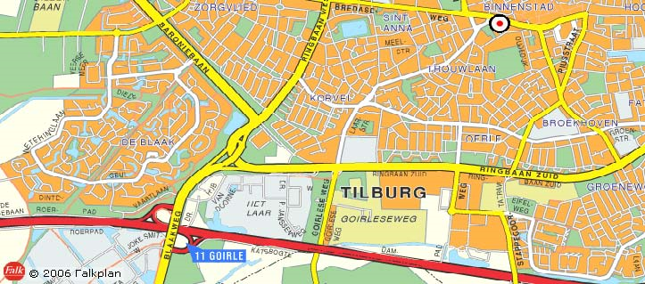
Loading/Unloading
loading and unloading trucks with 2 trailer lifts to
stage level.
max length trucks: 18.00m
narrowest passage to stage width 3.00m, height 6.00m

Dimensions
Stage opening
Fixed opening width 13.70m
height 8.70m
Variable opening width 10.00m
max 15.80m
height 0.00m
max 8.15m
Stagefloor width 21.00m
From KK (point zero) depth 12.00m
From front of stage 15.00m
From front of orchestra pit 18.00m

Stage including sides width 34.00m
From KK (point zero) depth 14.70m

Distances from point zero
Front of stage -3.00m
Back wall 14.70m
Back wall hall -19.60m
House curtain -1.51m
Advance bar -1.42m
Front of manteau -0.79m
Back of safety curtain -1.78m

Heights compared to stage floor:
Roof 20.70m
Max bar height 19.00m
Side bridge variable
Landings 9.15m

Capacity
Total 877
auditorium incl. chairs on orchestra pit 544
First balcony 169
Second balcony 164
Orchestra pit 39
Sound Seats, maximum 16, 2 x 8

Stage Floor
Solid floor Hardwood (Keroewing)
Thickness 28mm
Max. load 500kg/m2
Ballet floor Dimensions 12x15mm
Color black
Width per lane 1,60m

Masking/Drapery

House curtain
Color Red/Green
Operation Stage left
Greece – by hand
Wagner – electrical

Masking
Color Nightblue

12 legs height 10.00m
width 5.5m

6 borders height 4.00m
width 21.00m

8 backdrop legs height 10:00m
width 5.5m

1 backdrop height 10.00m
width 21.00m

6 up down legs height 9.00m
width 4.50m

1 cyclorama height 10.00m
width 21.00m

1 gauze height 9.00m
width 16.00m
Fly System
The fly system is computer controlled with a TNM system of manufacturer Trekwerk.
All bars except the hall bars and 2 up down bars are connected to this system.
The load capacity of lifting equipment is assessed according NPR8020-10 with a safety factor 10 (hoist
above persons).
The mentioned SWL / WLL on lifting materials must therefore be halved. Hoisting equipment in Theaters Tilburg is performed with a safety factor of 10. Hanging of loads is only permitted with certified lifting equipment. This all for review of the stage manager on duty in Theaters Tilburg. Operation of the hoisting equipment is only done by Theaters Tilburg staff.

Décor bars
60 bars (including advance bar)
rod length 21.00 m
max. speed 1.7 m / s
rod distance 20 cm (excluding bar 02,20,38,56)
(Due to steel beams 30-35 cm)
Point zero distance to the first bar 00.38 m
max load handling see table below.

Up down bars
6 up down bars
2 on inside of side bridges, rod length 12.50m
2 on exterior of side bridges, rod length 11.50m
2 underneath side bridges (not via TNM)
max load see table below
max load bars underneath side bridges 300kg

Advance Bar
Rod Length 21.00m
max speed 1.7 m / s
distance to Point zero -01.42m
max load see table below

FOH Bars
3 hall bars serving sound rigging
1 right rod length 02.00m max load 500kg
1 left rod length 02.00m max load 500kg
1 in the middle, rod length 02.00 max load 300kg

1 bar underneath the first FOH bridge. Max load 300 kg

Point Bars
12 pointbars
4 fields in which a maximum of 3 lifting points can be placed
Max. load 500 kg
Lifting height 0.00m – 20.00m
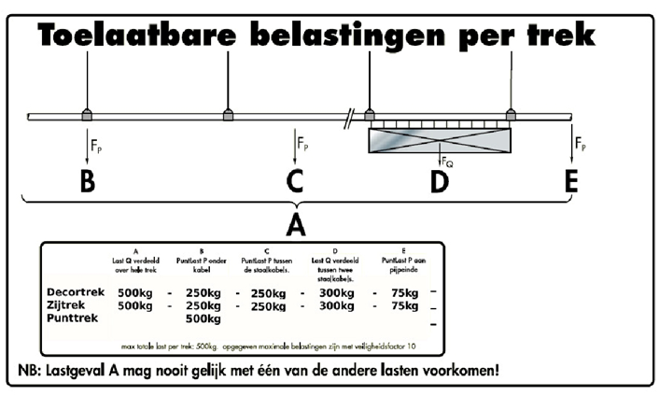
Orchestra pit
The orchestra pit is adjustable in height from orchestra pit level to stage level. The pit consists of a fixed level below the stage floor and the movable part in the hall.
Access to the pit floor at ground level both left and right through normal doors.
Supply of instruments via ground floor or stage level.
orchestra pit dimensions, see map
60 orchestra seats
50 desks, with lighting desk.
1 conductors desk
The desk lighting is dimmable via DMX controlled dimmers
Conductors camera, playback on regular monitoring left and right manteau
Dressing rooms
stage level
5 dressing rooms,
Ladies and gentlemen toilets, connection for 3
washers and 3 dryers, elevator to ground floor
dressing rooms 3, 2-4 persons, adjusted
disabled toilet.
dressing room 4, 2-4 persons, shower, sink
dressing room 5, 2-4 persons, shower, sink
dressing room 6, 2-4 persons, shower, sink
dressing room 7, 6-10 persons, sink
ground floor
3 dressing rooms
Ladies and gentlemen toilets, four shower rooms
dressing room 9, 4-8 persons, sink
dressing room 10, 12-25 persons, sinks
dressing room 11, 12-25 persons, sinks
stage sound and call from stage and control room

Grand piano
Steinway type B, 524797
length 1.90m x width 1.45m
Piano
Seiler 160630

Green Room
room for 50 people
36 seats
TV reception, monitor
stage image.
sound equipment, microphone.
stage sound and call from stage and control room
service available, times in consultation. Cold and hot drinks, catering in consultation
Main Power
All three phase power supply connections are
CEE standard red. 3 phase, neutral and earth.
1 piece 3x125 amp left front wall
1 piece 3x125 amp front right wall
1 piece 3x125 amp right side wall
2 pcs 3x63 amps right side wall
2 pcs 3x32 amps right side wall
1 pcs 3x32 amp front right wall (sound)
1 pcs 3x32 amp left side wall
1 pcs 3x32 amp left front wall (sound)
1 pcs 3x32 side bridge right
1 pcs 3x32 amp side bridge left
1 pcs 3x32 amp room bridge
1 pcs 3x16 amp right wall behind
The fair amount of 220 volt connections are
conducted in CEE and Shuko standard and are
spread throughout the theatre and bridges.

DMX
The DMX512 data network is installed as a
star network which meets on a patch right field,
in the patch unit there are 2 active opto-splitters available
each splitter with 1 in, 1 through, and 3 out.
All dmx cables are wired 5 cores and supplied with
5 pole neutrix.
DMX can be sent and received from:
control room, 4 lines
sound seats, 4 lines
stage left, 4 lines
stage right, 4 lines
stage left, two lines
stage right, two lines
side bridge left, two lines
side bridge right, 2 lines
portal bridge, 2 lines
foh bridge, 2 lines
operator table 1 line
for local splitting a portable active
opto-splitter is available.

Dimmers

The hall uses a decentral dimmer setup. At various locations there are dimmers type CompuDim. All dimmers are equipped with vending machines per fuse and earth leakage switches.
Per location, the dimmers provide the spots at that location and in addition they have multiple free connections executed with CEE and Harting han 16.The dimmers are located at the following locations:
stage left behind, stage right behind
manteau right, manteau left, portal bridge, up down bridge left and right
The dimmers for the foh bridges and the house lights are located at the dimmer
space at the ground floor
Free connections 2.5 kW per location
8 CEE manteau right
8 CEE manteau left
8 CEE up down bridge left
8 CEE up down bridge right
6 CEE portal bridge, 6 CEE under portal bridge,
8 CEE left stage behind
8 CEE right stage behind
2 Harting han16 manteau right
2 Harting han16 manteau left
2 Harting han16 side bridge left
4 Harting han 16 side bridge right (2 for cyclorama lights)
2 Harting han16 floor sinks right
2 Harting han16 floor sinks left

Free CEE connections 5 kW per location:
4 CEE side bridge left, 2 CEE side bridge right,
2 CEE cove right, 2 CEE cove left , 4 CEE first hall bridge
The main hall has a total of 265 dimmers, 120 of which are free dimmers.

Light desks
Roadhog 4 light control room
Roadhog 4 stage left
Compulite Princess for house lights, patch unit

Fixed Lights
First FOH bridge 20 pcs 2kW zoom profile
Second FOH bridge 20 pcs 2kW profile 17 °
Cove left 1 x 2kW zoom profile 23 °
1x 2kW zoom profile
2 x 2kW PC

Cove right 1 x 2kW zoom profile 23 °
1 x 2kW zoom profile
2 x 2kW PC
Portal bridge 12 pcs 1kW zoom profile
12 pcs 1kW PC
Manteau left 3 pcs 1kW PC
4 pcs 1 kW zoom profile
Manteau right 3 pcs 1kW PC
4 pcs 1 kW zoom profile
Up down bridge left 8 x 2kW profile 23 °
Up down bridge right 8 x 2kW profile 23 °
Cyclorama 14 pcs /mtr Robert Juliat Dalis Led Cyclight
Follow spot 2x Robert Juliat Victor 1800 Watt MSR

House lights
dimmed in 3 groups, dimmer channels 261 262 263

Curtain Light
2 x PC 1kW from FOH bridge dimmer channel 264

Conductor Light
2 x profile spot fixed position, dimmer channel 57-58

Orchestra reading lights
dimmed in one group dimmer channel 265

Bypass lights
Left, right and rear orbital led RGB
dimmable into 3 groups from patch unit stage left

Lighting Equipment
6 x sixbar with total 36 pcs 750W ETC par cans

12 x 750W ETC par can

16 x 1kw zoom profile Altmann

16 x 2kW PC with barndoors ADB
8 x 2kW PC with barndoors Robert Juliat

16 x 1kW PC with barndoors ADB

08 x 2 kW Fresnel DeSisti

08 x 1kW floodlight

10 x ballet tower with each 3 pieces 1 kW PC with barndoors CtC

Cabling
Various lengths multicable 18x1,5 Harting han16

Various lengths cables 3x2,5 CEE 16 amp male female
Various lengths cables 3x6 CEE 32 amp male female

Various lengths cables 3x1,5 shuko male female

Conversions CEE 16 male to shuko female
Conversions shuko male to CEE 16 female

20 shuko sockets male to 3 shuko sockets

2 break-in 8x CEE 16 Amp to Harting han 16
4 break-out unit Harting han 16 to 8 CEE sockets
12 break-out unit Harting han 16 to 8 shuko sockets

1 powercable 12,0 m 3x125 amp CEE 5p
1 split unit 3x125 amp 5p to 3x63 amp + 3 CEE 16 sockets + 3 shuko sockets
1 split unit 3x32 amp 5p to 3 CEE 16 sockets + 3 shuko sockets
Sound/Video
Meyer sound PA (active)
Array
7 pcs M'elody in FOH bar right
7 pcs M'elody in FOH bar left
1 piece CQ1 and 600-HP upstage right
1 piece CQ1 and 600-HP upstage left
2 pcs UPA as centre cluster in FOH bar middle
2 pcs UPM-2P infill on balconies left and right
2 pcs UPM-2P frontfill upstage left and right

Dsp
Digital sound processing by a Galileo-616 processor.
laptop and wi-fi present in consultation.

Monitoring
4 x d&B max 12
2 x d&B D6 amplifiers

Multicable
36 channel Harting Han 108 sound seats hall
36 x xlr stage left and right

Mixing Console
Digico SD11 and Digico SD9 (in consultation)
Stage right Digico D-rack

Besides the fixed installation Theaters Tilburg has a fairly wide range of mixers, microphones, transmitters, effects, CD / MD players, monitors and other peripherals with sufficient wiring.
In consultation per room available. For information and availability please contact the appropriate stage manager.

Cabling
Mickable xlr

Various lengths xlr-xlr

1 x snake reel 12 xlr 25 mtr
2 snake 4 xlr 15 mtr
2 snake 4 xlr 10 mtr
4 snake 4 xlr 5 mtr

Various lengths speakon speaker cable

Fixed Cabling
From patch stage right to sound Seats hall:
5 x coax cable bnc
5 x cat5 ethernetcable with rj45
36 p multicable xlr

from patch to lightbooth:
2 x cat5 ethernetcable with rj45
36 p. multicable xlr

From sound seats to lightbooth:
5 x coax kabel bnc
36 p. multicable xlr

From stage right to stage left:
36 p. multicable xlr
2 x cat5 eternetcable rj45
5 x coaxcable bnc

Video
Theaters Tilburg offers various audio visual equipment including projectors, multimedia PC’s and mixer / switching units. Availability and accessibility in consultation with the stage manager.

